LOW COST FARM STORAGE MONITORING
A PROJECT REPORT

Submitted by

SRIDHAR.B | 611223114100
YOGESWARI.G | 611223114115
SHARATH.M.R | 611223114094
MAHENDIRAN.M | 611223114054
in partial fulfillment for the award of the degree
Of

BACHELOR OF ENGINEERING
IN
MECHANICAL ENGINEERING

KNOWLEDGE INSTITUTE OF TECHNOLOGY,SALEM

ANNA UNIVERSITY::CHENNAI 600 025

DEC 2025

ANNA UNIVERSITY : CHENNAI 600 025

BONAFIDE CERTIFICATE

Certified that this project report " LOW COST FARM STORAGE MONITORING”
is the bonafide work of "SRIDHAR.B ,SHARATH.M.R,YOGESWARI.G MAHENDIRAN.M" who carried out the project work under my supervision.

SIGNATURE SIGNATURE

Dr.K.S.PRABHAKARAN.,M.E.,Ph.D. Prof.S.SURENDAR.,B.E.,M.E.
HEAD OF THE DEPARTMENT SUPERVISOR
PROFESSOR ASSISTANT PROFESSOR
DEPARTMENT OF MECHANICAL DEPARTMENT OFMECHANICAL
ENGINEERING ENGINEERING
KNOWLEDGE INSTITUTE OF KNOWLEDGE INSTITUTE OF
TECHNOLOGY TECHNOLOGY
KIOT CAMPUS KIOT CAMPUS
KAKAPALAYAM(PO) KAKAPALAYAM(PO)
SALEM-637504 SALEM-637504
ABSTRACT
Agriculture and greenhouse management require continuous monitoring of environmental conditions to ensure crop health, productivity, and safety. Temperature and humidity variations can significantly affect plant growth, livestock welfare, and storage conditions. Traditional monitoring methods rely on manual observation, which is time-consuming and often unable to provide immediate responses to changing environmental conditions.This project presents an IoT-Based Smart Farm Monitoring and Automatic Ventilation System using an ESP32 microcontroller, DHT22 temperature and humidity sensor, relay module, exhaust fan, buzzer, LCD display, and the Blynk IoT cloud platform. The DHT22 sensor continuously measures temperature and humidity levels, while the ESP32 processes the data and displays real-time readings on a 16×2 I2C LCD display. The collected data is also transmitted to the Blynk cloud platform through Wi-Fi, enabling remote monitoring, cloud-based data storage, graphical visualization, and real-time access through the Blynk mobile application.To enhance environmental safety and automation, the system incorporates an automatic ventilation mechanism. When the temperature exceeds 35°C, the ESP32 activates an exhaust fan through a relay module and simultaneously triggers a buzzer alarm. When the temperature falls below the threshold value, both the fan and buzzer are automatically turned off. The proposed system provides a low-cost, energy-efficient, and user-friendly solution for smart agriculture applications, offering real-time monitoring, automatic environmental control, remote accessibility, and improved farm management efficiency.

KEYWORDS:
Agricultural Extension, Agroecology, Agri-logistics, Agri-supply Chain,Low-Cost Systems, Remote Monitoring

TABLE OF CONTENT

CHAPTER NO. | TITLE | PAGE NO.
 | ABSTRACT | i
 | LIST OF TABLES | vi
 | LIST OF FIGURES | x
 | LIST OF SYMBOLS & ABBREVIATIONS | vi
1 | INTRODUCTION | 1
 | 1.1 Overview of Farm Produce Storage | 2
 | 1.2 Problems in Traditional Storage Methods | 2
 | 1.3 Need for Low Cost Storage Monitoring | 3
 | 1.4 Importance of Monitoring Temperature and Humidity | 3
 | 1.5 Objectives of the Project | 4
 | 1.6 Methodology | 5
2 | LITERATURE SURVEY | 6
 | 2.1 Review of Farm Storage Techniques | 7
 | 2.2 Post-Harvest Losses in Agriculture | 7
 | 2.3 Temperature and Humidity Control in Storage | 8
 | 2.4 IoT and Sensor-Based Monitoring Systems | 9
 | 2.5 Research Gap and Motivation | 9
3 | PRINCIPLES OF FARM STORAGE MONITORING | 11
 | 3.1 Introduction | 11
 | 3.2 Effect of Temperature on Stored Crops | 11
 | 3.3 Effect of Humidity on Farm Produce | 12
 | 3.4 Spoilage Mechanisms and Shelf Life | 12
 | 3.5 Importance of Real-Time Monitoring | 13
 | 3.6 Low-Cost Monitoring Approach | 14
4 | SYSTEM DESIGN AND COMPONENT DESCRIPTION | 15
 | 4.1 Introduction | 15
 | 4.2 Overall System Architecture | 15
 | 4.3 Block Diagram Description | 16
 | 4.4 Components List | 17
 | 4.5 Component Description | 17
 | 4.5.1 ESP32 Microcontroller | 17
 | 4.5.2 DHT22 Temperature Sensors | 18
 | 4.5.3 BUZZER | 19
 | 4.5.4 DISPLAY I2C | 20
 | 4.5.5 Power Supply Unit | 21
 | 4.5.6 FARM STORAGE Structural Elements | 22
 | 4.6 Design Considerations | 23
 | 4.7 System Advantages | 23
5 | CIRCUIT DESIGN AND CONNECTIONS | 24
 | 5.1 Introduction | 24
 | 5.2 Circuit Diagram | 24
 | 5.3 Pin Configuration of ESP32 | 25
 | 5.4 Sensor Wiring and Connections | 26
 | 5.5 BUZZER | 26
 | 5.6 DISPLAY I2C | 27
 | 5.7 Power Supply Arrangement | 27
 | 5.8 Circuit Reliability and Safety Measures | 28
6 | WORKING PRINCIPLE | 29
 | 6.1 Introduction | 29
 | 6.2 Sensing and Data Acquisition Process | 29
 | 6.3 Monitoring and Display Operation | 30
 | 6.4 Data Logging and Alert Mechanism | 30
 | 6.5 Overall System Flow | 31
7 | EXPERIMENTAL SETUP AND IMPLEMENTATION | 32
 | 7.1 Introduction | 32
 | 7.2 Description of Storage Model | 32
 | 7.3 Sensor Placement in Storage | 33
 | 7.4 Hardware Setup | 33
 | 7.5 Software Implementation | 34
 | 7.6 Calibration and Testing | 35
 | 7.7 Experimental Procedure | 35
 | 7.8 Data Collection and Analysis Preparation | 36
8 | COST ESTIMATION | 37
 | 8.1 Introduction | 37
 | 8.2 Cost Estimation Methodology | 37
 | 8.3 Component-Wise Cost Breakdown | 38
 | 8.4 Economic Feasibility | 38
 | 8.5 Comparison with Conventional Storage Systems | 39
9 | RESULT AND ANALYSIS | 40
 | 9.1 Introduction | 40
 | 9.2 Temperature Data Collection | 40
 | 9.3 Storage Condition Evaluation | 41
 | 9.4 Performance of Monitoring System | 41
 | 9.5 Reduction in Spoilage Risk | 42
 | 9.6 Graphical Representation of Results | 42
 | 9.7 Limitations of the System | 43
10 | ADVANTAGES AND APPLICATION | 44
 | 10.1 Introduction | 44
 | 10.2 Advantages of Low Cost Storage Monitoring | 44
 | 10.2.1 Energy Efficiency | 44
 | 10.2.2 Cost Effectiveness | 44
 | 10.2.3 Environmentally Friendly | 45
 | 10.2.4 Improved Thermal Comfort | 45
 | 10.2.5 Low Maintenance Requirements | 45
 | 10.2.6 Scalability and Adaptability | 46
 | 10.3 Applications in Agriculture | | 46
 | 10.3.1 Grain Storage | 46
 | 10.3.2 Vegetable Storage | 47
 | 10.3.3 Fruit Storage | 47
 | 10.3.4 Cold Storage Support Systems | 47
11 | APPENDICES | 48
 | 11.1 FIELD VISIT | 48
 | 11.2 PROTOTYPE | 49
12 | CONCLUSION | 51
13 | REFERENCES | 52

Table No. | Title | Page No.
Table 4.4 | List of Components | 31
Table 5.3 | ESP32 Pin Configuration | 39
Table 8.3 | Cost Estimation of Components | 52

LIST OF SYMBOLS, ABBREVIATIONS AND NOMENCLATURE

1.SYMBOLS:

Symbol | Meaning
°C | Degrees Celsius
% | Percentage
mA | Milliampere
kΩ | Kilo Ohms
°F | Degree Fahrenheit
kJ | Kilojoule
Pa | Pascal

2.ABBREVIATIONS:

Abbreviation | Full Form
ESP | Espressif Systems Processor
ADC | Analog to Digital Converter
SD | Secure Digital
I2C | Inter-Integrated Circuit
GPIO | General Purpose Input/Output
SPI | Serial Peripheral Interface
PSU | Power Supply Unit
ADC | Analog to Digital Converter
Wi-Fi | Wireless Fidelity

3.NOMENCLATURE:

Term | Definition / Description
Agricultural Extension | Services providing farmers with knowledge on farm practices.
Agroecology | Ecological processes applied to agricultural production.
Agri-logistics | Management of agricultural product flows from farm to storage.
Agri-supply Chain | Network moving produce from farm to consumer.
Agro-processing | Transformation of agricultural produce into products.
Agribusiness | Commercial enterprises in agriculture.
Food Security | 7. Access to sufficient safe food.
Post-harvest Management | Handling produce after harvest to reduce loss.
Smallholder Farming | Small-scale farms common in developing regions.
Farm-to-Fork | Integrated supply chain concept for food safety and quality
Storage Monitoring | Real-time observation of storage conditions.
Low-Cost Systems | Affordable hardware/software for resource-limited farms.
Remote Monitoring | Observing storage conditions from a distance.
Real-Time Data | 14. Immediate data reporting from sensors.
Alert System | Notification mechanism when conditions deviate.
Environmental Control | Management of humidity/temperature in storage.
Data Logging | Recording data over time for analysis.
Wireless Sensor Networks (WSN) | Distributed sensors communicating wirelessly.
Thresholds | Predefined safe limits for environmental parameters.
Monitoring Dashboard | Interface to view sensor data
Dew Point | 23. Temperature at which air becomes saturated.
CO₂ Levels | Carbon dioxide concentration in storage.
Ethylene Gas | Ripening hormone commonly monitored.
Light Exposure | Intensity of light affecting produce quality.
Airflow | Movement of air within storage.
Moisture Content | Water amount in produce.
Soil Moisture Sensor | Measures water in soil for produce like bulbs.
Infrared Sensor | Non-contact temperature sensing.
Accelerometer | Detects motion and vibration.
Raspberry Pi | Small computer for system control.
LoRaWAN | Long-range low power networking.
Zigbee | Low-power mesh networking protocol.
API | Interface for system integration.
ESP32 Microcontroller | A low-power, high-performance microcontroller used for data acquisition and processing
Big Data | Large datasets from sensor networks.
Digital Temperature Measurement | Temperature sensing using digital output signals
Sensor-Based Monitoring System | System that collects environmental data using sensors
Real-Time Clock (RTC) | Module that keeps track of current date and time
Cloud Storage | Internet hosting of data.
Predictive Analytics | Forecasting future trends.
Anomaly Detection | Identifying abnormal patterns.
Energy Harvesting | Power from environment sources.
Ambient Storage | Non-cooled storage spaces.
Modified Atmosphere Storage | Controlled gas composition.
Controlled-Atmosphere (CA) | Precisely controlled environment.
Silos | Vertical grain storage.
Hermetic Bags | Airtight storage for grains.
Insulated Containers | Reduce thermal exchange.
Sustainable Residential Design | Housing design that emphasizes energy efficiency and sustainability
Post-Harvest Loss | Loss after harvest before consumption.
Decay Rate | Speed of spoilage.
Bruise Detection | Identifies physical damage.
Dew Formation | Water droplets from temperature changes.
Alert Prioritization | Ranking critical notifications.
Threshold Breach | When parameter exceeds safe limits.

LIST OF FIGURES:

Figure No. | Title | Page No
Figure 4.1 | ESP32 Microcontroller | 37
Figure 4.2 | DHT22 Temperature Sensors | 38
Figure 4.3 | BUZZER | 39
Figure 4.4 | DISPLAY I2C | 40
Figure 4.4 | Power Supply Unit | 41
Figure 9.1 | Data collection
Figure 11.1 | Field visit | 66
Figure 11.2 | Field visit | 66
Figure 11.3 | Field visit | 66
Figure 11.4 | Prototype | 67
Figure 11.5 | Prototype | 67
Figure 11.6 | Prototype | 68

CHAPTER 1
INTRODUCTION

Agriculture plays a vital role in ensuring food security and economic growth. Environmental factors such as temperature and humidity have a significant impact on crop growth, greenhouse productivity, and livestock health. Traditional monitoring methods rely on manual observation, which is time-consuming and often unable to detect sudden environmental changes. Therefore, there is a growing need for intelligent systems that can continuously monitor farm conditions and provide timely responses to unfavorable situations.
The Internet of Things (IoT) has emerged as an effective solution for modern agricultural monitoring. IoT-based systems use sensors, microcontrollers, cloud platforms, and wireless communication technologies to collect, process, and transmit environmental data in real time. In this project, an ESP32 microcontroller and DHT22 temperature and humidity sensor are used to monitor environmental conditions. The measured data is displayed on a 16×2 I2C LCD and transmitted to the Blynk cloud platform, enabling remote monitoring and data visualization through a mobile application.
To enhance farm safety and environmental control, an automatic ventilation system is integrated into the project. When the temperature exceeds 35°C, the ESP32 activates an exhaust fan through a relay module and triggers a buzzer alarm to indicate high-temperature conditions. Once the temperature returns below the threshold value, the fan and buzzer are automatically turned off. The system also allows remote fan control through the Blynk application. The proposed system provides a low-cost, energy-efficient, and user-friendly solution for smart agriculture, greenhouse management, and environmental monitoring applications.

  - Overview of Farm Produce Storage
Smart farm monitoring is a modern agricultural approach that uses sensors, microcontrollers, and Internet of Things (IoT) technology to continuously observe environmental conditions affecting crop growth and farm productivity. Parameters such as temperature and humidity play a significant role in maintaining a healthy farming environment. Continuous monitoring of these parameters helps farmers identify unfavorable conditions at an early stage, enabling timely corrective actions and improving overall farm efficiency.
Traditional monitoring methods rely on manual observation, which can be time-consuming and may not provide immediate information about environmental changes. The IoT-Based Smart Farm Monitoring and Automatic Ventilation System overcomes these limitations by using a DHT22 sensor and ESP32 microcontroller to measure and process environmental data in real time. The collected data is displayed on an LCD screen and transmitted to the Blynk cloud platform for remote monitoring. This enables farmers to access live environmental information, receive alerts, and maintain optimal farm conditions through automatic ventilation and remote control features.
1.2 Problems in Traditional Storage Methods
Traditional farm monitoring methods mainly depend on manual observation and periodic inspection of environmental conditions. Farmers often check temperature and humidity levels manually, which can be time-consuming and may not provide accurate information about sudden changes in the farm environment. As a result, unfavorable conditions such as excessive heat or high humidity may go unnoticed until they begin to affect crop growth, greenhouse conditions, or livestock health.
Another major limitation of traditional monitoring methods is the lack of real-time data and automated control. Since environmental conditions are not continuously monitored, corrective actions are often delayed, leading to reduced productivity and potential losses. Furthermore, traditional methods do not support remote monitoring, requiring farmers to be physically present for inspection. These challenges highlight the need for an IoT-based smart monitoring system that can provide continuous observation, instant alerts, remote accessibility, and automatic environmental control.
1.3 Need for Low Cost Storage Monitoring
The agricultural sector increasingly requires efficient monitoring systems to maintain suitable environmental conditions and improve farm productivity. However, many advanced monitoring solutions available in the market are expensive and difficult for small and medium-scale farmers to adopt. As a result, farmers often rely on manual monitoring methods, which may fail to detect sudden changes in temperature and humidity, leading to reduced crop yield and unfavorable farming conditions.
A low-cost smart farm monitoring system provides an affordable solution by utilizing economical sensors, microcontrollers, and IoT technology to continuously monitor environmental parameters. Real-time monitoring and automatic ventilation help farmers take timely corrective actions, preventing damage caused by excessive temperature and humidity. By offering remote accessibility, cloud-based monitoring, and automated control at a reasonable cost, the system becomes practical and accessible for a wide range of agricultural applications.
1.4 Importance of Monitoring Temperature and Humidity
Temperature and humidity are two of the most important environmental factors affecting agricultural productivity and farm conditions. Excessive temperature can cause heat stress in plants and livestock, reduce crop growth, and increase water loss, while high humidity can promote the growth of fungi, bacteria, and other harmful microorganisms. Maintaining these parameters within suitable limits is essential for ensuring healthy crop development and improving overall farm efficiency.
Continuous monitoring of temperature and humidity enables farmers to detect unfavorable environmental conditions at an early stage and take corrective actions promptly. Real-time monitoring systems provide accurate data and instant alerts whenever the measured values exceed predefined thresholds. This helps maintain a stable farm environment, reduces the risk of crop damage, improves productivity, and supports efficient farm management through automated control and remote monitoring capabilities.
1.5 Objectives of the Project
The primary objective of this project is to develop an IoT-Based Smart Farm Monitoring and Automatic Ventilation System that can continuously monitor environmental conditions and provide automatic control to maintain a suitable farming environment. The system aims to improve farm safety, productivity, and efficiency through real-time monitoring and remote accessibility.
- To monitor temperature and humidity levels in real time using the DHT22 sensor.
- To display environmental data on a 16×2 I2C LCD display.
- To transmit sensor data to the Blynk cloud platform for remote monitoring and data visualization.
- To automatically activate an exhaust fan through a relay module when the temperature exceeds 35°C.
- To provide an audible alert using a buzzer during high-temperature conditions.
- To allow manual control of the exhaust fan through the Blynk mobile application.
- To develop a low-cost, energy-efficient, and user-friendly solution for smart agriculture and greenhouse monitoring applications.
1.6 Methodology
The methodology of the proposed IoT-Based Smart Farm Monitoring and Automatic Ventilation System involves sensing, processing, monitoring, and automatic control of environmental conditions. The DHT22 sensor continuously measures temperature and humidity levels in the farm environment and sends the collected data to the ESP32 microcontroller. The ESP32 processes the sensor readings and displays the real-time values on a 16×2 I2C LCD display for local monitoring.
The processed data is transmitted to the Blynk cloud platform through the ESP32's built-in Wi-Fi module, enabling remote monitoring and data visualization using the Blynk mobile application. The system continuously compares the measured temperature with a predefined threshold value of 35°C. When the temperature exceeds this limit, the ESP32 activates an exhaust fan through a relay module and simultaneously triggers a buzzer alarm. Once the temperature falls below the threshold, the fan and buzzer are automatically turned off.

CHAPTER 2
LITERATURE SURVEY

The rapid growth of Internet of Things (IoT) technology has brought significant improvements to the agricultural sector by enabling real-time monitoring and intelligent control of environmental conditions. Smart farming systems integrate sensors, microcontrollers, wireless communication technologies, and cloud platforms to continuously collect and analyze data related to temperature, humidity, soil moisture, and other important parameters. These technologies help farmers improve productivity, optimize resource utilization, and maintain favorable conditions for crop growth and livestock management.
In recent years, researchers have developed various IoT-based agricultural monitoring systems to address challenges associated with traditional farming methods. These systems provide continuous environmental monitoring, automated alerts, and remote access through cloud-based platforms and mobile applications. By enabling farmers to monitor farm conditions from any location, IoT technology improves decision-making and reduces the risk of crop damage caused by unfavorable environmental changes.
Many existing studies have focused on temperature and humidity monitoring, cloud-based data logging, automated environmental control, and smart greenhouse management. The literature survey presented in this chapter examines previous research works related to smart farm monitoring, IoT-based automation, wireless communication, and automatic ventilation systems. The review helps identify current technological advancements, existing limitations, and the need for a low-cost and efficient IoT-Based Smart Farm Monitoring and Automatic Ventilation System.
2.1 Review of Farm Storage Techniques
Smart farm monitoring techniques have evolved significantly with the advancement of sensor technology, wireless communication, and IoT platforms. Traditional monitoring methods relied on manual observation of environmental conditions, which often resulted in delayed responses to temperature and humidity variations. Modern monitoring systems use sensors and microcontrollers to continuously collect environmental data and provide real-time information to farmers, enabling better farm management and decision-making.
Various researchers have developed automated monitoring systems that utilize temperature and humidity sensors, wireless sensor networks, and cloud-based platforms to observe farm conditions continuously. These systems provide accurate environmental data, generate alerts when parameters exceed predefined limits, and allow remote monitoring through mobile applications. The integration of IoT technology has improved the efficiency, reliability, and accessibility of agricultural monitoring systems.
Recent smart farm monitoring techniques also incorporate automated control mechanisms such as ventilation systems, irrigation control, and environmental regulation. These features help maintain optimal farming conditions while reducing manual effort and operational costs. The combination of real-time sensing, cloud connectivity, and automatic control has made smart farm monitoring an effective solution for improving agricultural productivity and sustainability.
2.2 Post-Harvest Losses in Agriculture
Post-harvest losses refer to the reduction in the quantity and quality of agricultural produce after harvesting due to improper storage, handling, transportation, and unfavorable environmental conditions. Factors such as high temperature, excessive humidity, pest infestation, and microbial growth can accelerate the deterioration of crops, leading to significant economic losses for farmers. These losses not only affect farmers' income but also reduce food availability and increase overall wastage.
Temperature and humidity are among the most critical factors influencing the preservation of agricultural products. Uncontrolled environmental conditions can promote spoilage, fungal growth, and quality degradation, reducing the shelf life of produce. Continuous monitoring of these parameters helps in the early detection of unfavorable conditions, allowing timely corrective actions. Therefore, implementing smart monitoring systems can play an important role in minimizing post-harvest losses and maintaining the quality and safety of agricultural products.
2.3 Temperature and Humidity Control in Storage
Temperature and humidity control are essential for maintaining the quality and safety of agricultural produce during storage. Excessive temperature can accelerate spoilage, increase respiration rates, and reduce the shelf life of stored products. Similarly, high humidity levels can promote the growth of fungi, molds, and bacteria, leading to quality degradation and economic losses. Therefore, maintaining optimal environmental conditions is crucial for preserving agricultural products and minimizing wastage.
Modern monitoring systems use temperature and humidity sensors to continuously observe environmental conditions and provide real-time information. When the measured values exceed predefined limits, automatic control mechanisms such as ventilation fans, cooling systems, and alert devices can be activated to restore suitable conditions. Effective temperature and humidity control not only improves storage efficiency but also helps in reducing post-harvest losses, maintaining product quality, and enhancing overall agricultural sustainability.
2.4 IoT and Sensor-Based Monitoring Systems
The Internet of Things (IoT) has emerged as a powerful technology for monitoring and managing agricultural environments. IoT-based monitoring systems use sensors, microcontrollers, wireless communication networks, and cloud platforms to collect, process, and transmit environmental data in real time. These systems enable continuous observation of parameters such as temperature, humidity, soil moisture, and air quality, allowing farmers to monitor farm conditions remotely and make informed decisions.
Sensor-based monitoring systems provide accurate and reliable measurements of environmental conditions and help detect abnormal situations at an early stage. The collected data can be displayed locally or transmitted to cloud platforms for remote access, data logging, and analysis. By integrating IoT technology with automated control mechanisms, these systems improve efficiency, reduce manual effort, and support sustainable agricultural practices through real-time monitoring and intelligent environmental management.
2.5 Research Gap and Motivation
Although numerous IoT-based agricultural monitoring systems have been developed, many existing solutions focus primarily on environmental monitoring without providing automatic control features. Some systems are costly, require complex installation, or lack cloud-based remote monitoring capabilities, making them unsuitable for small and medium-scale farmers. Additionally, several monitoring systems only generate alerts when environmental conditions become unfavorable, requiring manual intervention to restore suitable conditions.
The motivation for this project is to develop a low-cost, efficient, and user-friendly IoT-Based Smart Farm Monitoring and Automatic Ventilation System that combines real-time monitoring, cloud connectivity, automatic ventilation control, and remote accessibility. By integrating an ESP32 microcontroller, DHT22 sensor, relay-controlled exhaust fan, buzzer alert, LCD display, and the Blynk cloud platform, the proposed system aims to provide an affordable solution that enhances farm safety, improves environmental management, and supports smart agricultural practices.

CHAPTER 3
PRINCIPLES OF FARM STORAGE MONITORING

3.1 Introduction
Farm monitoring plays an important role in modern agriculture by helping farmers maintain suitable environmental conditions for crops, greenhouses, and livestock. Parameters such as temperature and humidity have a direct impact on plant growth, productivity, and overall farm health. Continuous monitoring of these environmental factors enables early detection of unfavorable conditions, allowing timely corrective actions to improve agricultural efficiency and reduce losses.
With the advancement of IoT technology, smart farm monitoring systems have become more effective and accessible. These systems use sensors, microcontrollers, wireless communication, and cloud platforms to collect and analyze environmental data in real time. The IoT-Based Smart Farm Monitoring and Automatic Ventilation System continuously monitors temperature and humidity, displays the readings locally, and transmits data to the cloud for remote monitoring. It also provides automatic ventilation and alert mechanisms to maintain a stable and safe farm environment.
3.2 Effect of Temperature on Stored Crops
Temperature is one of the most important factors affecting the quality and shelf life of stored agricultural products. High temperatures increase the rate of respiration and metabolic activities in crops, leading to faster deterioration and reduced storage life. Excessive heat can also encourage the growth of microorganisms, insects, and pests, resulting in spoilage and economic losses. On the other hand, extremely low temperatures may cause chilling or freezing injuries in certain fruits and vegetables, affecting their texture, appearance, and nutritional value.
Maintaining an appropriate temperature range is essential for preserving the quality and safety of stored crops. Continuous temperature monitoring helps detect unfavorable conditions at an early stage and allows timely corrective actions such as ventilation or cooling. By ensuring stable temperature conditions, storage facilities can reduce post-harvest losses, extend shelf life, and maintain the market value of agricultural produce.
3.3 Effect of Humidity on Farm Produce
Humidity is a critical environmental factor that influences the quality, safety, and storage life of agricultural produce. High humidity levels create favorable conditions for the growth of fungi, molds, and bacteria, which can lead to spoilage and quality deterioration. Excess moisture may also cause discoloration, unpleasant odors, and loss of market value. In severe cases, prolonged exposure to high humidity can make agricultural products unsafe for consumption.
Low humidity levels can also negatively affect farm produce by causing excessive moisture loss, shrinkage, wilting, and weight reduction. Such conditions can reduce the freshness and appearance of fruits, vegetables, and other agricultural products. Therefore, continuous monitoring and control of humidity are essential for maintaining optimal storage conditions, preserving product quality, and reducing post-harvest losses.
3.4 Spoilage Mechanisms and Shelf Life
Spoilage of agricultural produce occurs due to a combination of biological, chemical, and physical processes that reduce quality and safety during storage. Factors such as microbial growth, insect infestation, oxidation, and enzymatic reactions contribute to the deterioration of crops over time. These processes are strongly influenced by environmental conditions, particularly temperature and humidity. Unfavorable storage conditions accelerate spoilage, resulting in quality degradation, reduced nutritional value, and economic losses for farmers.
Shelf life refers to the period during which agricultural products remain safe and suitable for consumption under specific storage conditions. Proper monitoring of environmental parameters helps maintain favorable conditions and slows down spoilage processes, thereby extending shelf life. Continuous observation of temperature and humidity enables early detection of abnormal conditions, allowing timely corrective actions to preserve product quality and minimize post-harvest losses.
3.5 Importance of Real-Time Monitoring
Real-time monitoring is essential in agricultural environments because temperature and humidity conditions can change rapidly due to weather variations, ventilation issues, and biological activities. Periodic manual inspections may fail to detect sudden environmental changes, allowing unfavorable conditions to persist and cause damage before corrective actions are taken. Continuous monitoring ensures that important environmental parameters are observed at all times, reducing the risk of crop deterioration and productivity loss.
By continuously collecting and analyzing environmental data, real-time monitoring systems can immediately detect abnormal conditions and generate alerts or activate control mechanisms. This enables farmers to respond quickly by improving ventilation, adjusting environmental settings, or taking other preventive measures. Real-time monitoring not only enhances farm management efficiency but also supports better decision-making, improves product quality, and reduces losses caused by unfavorable environmental conditions.

3.6 Low-Cost Monitoring Approach
A low-cost monitoring approach is essential for making smart agricultural technologies accessible to small and medium-scale farmers. Many advanced monitoring systems available in the market are expensive and require complex infrastructure, limiting their adoption in rural areas. By utilizing affordable components such as the ESP32 microcontroller, DHT22 sensor, relay module, buzzer, and LCD display, an effective monitoring system can be developed at a reasonable cost without compromising functionality and reliability.
The proposed system combines low-cost hardware with IoT technology to provide real-time environmental monitoring, automatic ventilation control, and remote accessibility through the Blynk cloud platform. The use of readily available components reduces installation and maintenance costs while ensuring accurate monitoring of temperature and humidity. This approach enables farmers to benefit from modern smart farming technologies, improve environmental management, and increase agricultural productivity without significant financial investment.

CHAPTER 4
SYSTEM DESIGN AND COMPONENT DESCRIPTION

4.1Introduction
The IoT-Based Smart Farm Monitoring and Automatic Ventilation System is designed to monitor environmental conditions and provide automatic control to maintain a suitable farming environment. The system continuously measures temperature and humidity using a DHT22 sensor and processes the collected data through an ESP32 microcontroller. Real-time readings are displayed on an LCD screen and transmitted to the Blynk cloud platform, enabling remote monitoring and data visualization through a mobile application.
The system also incorporates an automatic ventilation mechanism to improve farm safety and environmental stability. When the temperature exceeds a predefined threshold, the ESP32 activates an exhaust fan through a relay module and triggers a buzzer alarm. Once the temperature returns to a safe level, the fan and buzzer are automatically turned off. This chapter describes the overall system design and the hardware components used to achieve efficient monitoring, cloud connectivity, and automatic environmental control.
4.2 Overall System Architecture
The overall architecture of the IoT-Based Smart Farm Monitoring and Automatic Ventilation System consists of sensing, processing, communication, display, and control units working together to monitor environmental conditions and provide automatic ventilation. The DHT22 sensor continuously measures temperature and humidity levels from the farm environment and sends the collected data to the ESP32 microcontroller. The ESP32 acts as the central processing unit, analyzing the sensor readings and making control decisions based on predefined threshold values.
The processed data is displayed on a 16×2 I2C LCD display for local monitoring and simultaneously transmitted to the Blynk cloud platform through the ESP32's built-in Wi-Fi module. Users can access real-time environmental data and control the exhaust fan remotely using the Blynk mobile application. When the temperature exceeds 35°C, the ESP32 activates a relay module that switches on the exhaust fan and triggers a buzzer alarm. Once the temperature falls below the threshold value, the relay turns off the fan and the buzzer is deactivated. This architecture ensures continuous monitoring, cloud connectivity, remote accessibility, and automatic environmental control for smart farming applications.
4.3 Block Diagram Description
The block diagram of the IoT-Based Smart Farm Monitoring and Automatic Ventilation System consists of a DHT22 temperature and humidity sensor, ESP32 microcontroller, 16×2 I2C LCD display, relay module, exhaust fan, buzzer, and the Blynk cloud platform. The DHT22 sensor continuously measures environmental conditions and sends the collected data to the ESP32, which acts as the central processing unit. The ESP32 processes the sensor readings and displays the real-time temperature and humidity values on the LCD screen for local monitoring.
The ESP32 also transmits the sensor data to the Blynk cloud platform through Wi-Fi, enabling remote monitoring and control through a mobile application. When the temperature exceeds the predefined threshold of 35°C, the ESP32 activates the relay module, which switches on the exhaust fan and triggers the buzzer alarm. Once the temperature falls below the threshold value, the fan and buzzer are automatically turned off. This block diagram illustrates the complete flow of data and control within the system, ensuring efficient environmental monitoring and automatic ventilation.
4.4 Components List
LIST OF COMPONENTS:
S. No. | Component Name | Description / Purpose
1 | ESP32 Microcontroller | Main control unit for data acquisition and processing
2 | DHT22 Temperature Sensors (2 Nos.) | Measures temperature at two different points
3 | BUZZER | alert indication
4 | DISPLAY I2C | based display unit
5 | Power Supply Unit | Supplies required power to the system
6 | Connecting Wires and Breadboard | Used for circuit connections and prototyping

4.5 Component Description
4.5.1 ESP32 Microcontroller
The ESP32 is a powerful, low-cost microcontroller with integrated Wi-Fi and Bluetooth capabilities. It is selected for this project due to its high processing speed, low power consumption, and multiple GPIO pins. The ESP32 processes temperature data received from the sensors and controls data logging operations.

The microcontroller supports digital communication protocols such as I²C and SPI, which are used to interface the DHT22 and Buzzer. Its reliability and flexibility make it suitable for continuous temperature monitoring applications.
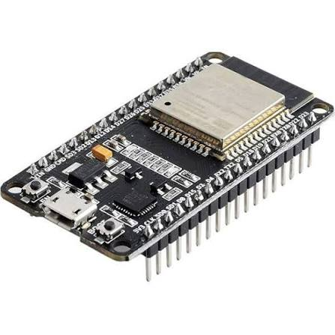
FIGURE 4.1

4.5.2 DHT22 Temperature Sensors
The DHT22 sensor is used to measure temperature and relative humidity inside the farm storage structure. It provides digital output with improved accuracy and stability compared to basic sensors. Accurate temperature and humidity measurement is essential to prevent spoilage and maintain crop quality.
Continuous monitoring using the DHT22 allows the system to detect environmental fluctuations early and initiate timely alerreducing post-harvest
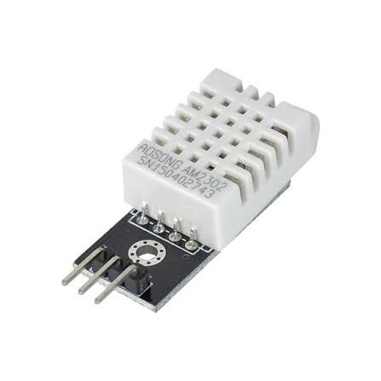 .

FIGURE 4.2
4.5.3 Buzzer
The buzzer acts as an audible alert device in the system. It is activated whenever temperature or humidity levels exceed predefined safe limits. The buzzer provides immediate warning to the user, even if the display is not continuously monitored.

The use of a buzzer ensures quick response in farm environments where visual attention may be limited. Its low power consumption and simple control make it
suitable for low-cost monitoring systems.
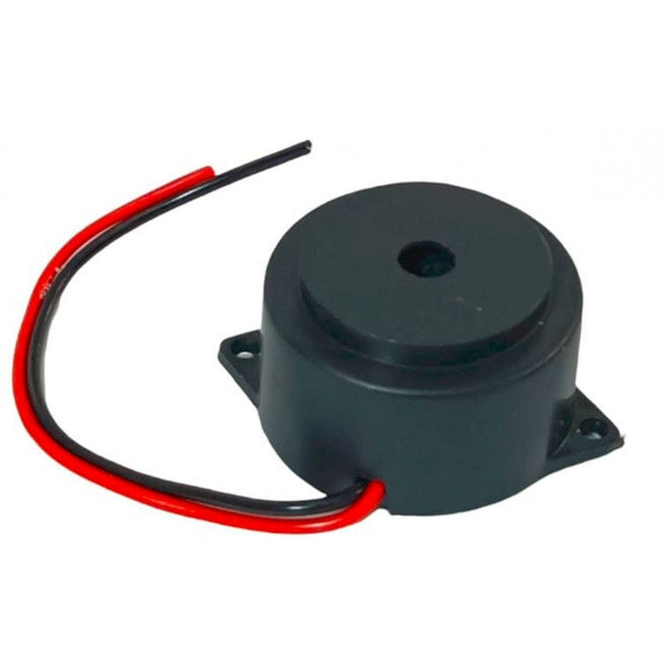
FIGURE 4.3

4.5.4 Display (I2C)
The I2C-based display unit is used to show real-time temperature and humidity values along with system status messages. The I2C interface reduces wiring complexity and allows efficient communication between the display and the ESP32 microcontroller.

The display enhances user interaction by providing clear and easily readable information. It allows farmers to visually monitor storage conditions and understand alert situations without the need for additional

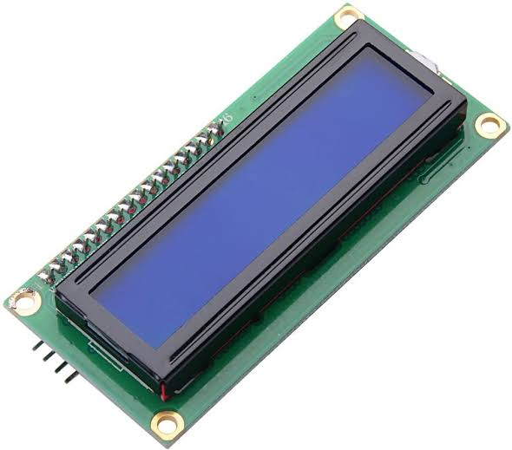
FIGURE 4.4

4.5.5 Power Supply Unit
The power supply unit provides regulated voltage to all electronic components in the system. A stable power supply is essential for accurate sensor readings and reliable system operation.

The system can be powered using a DC adapter or a rechargeable battery, depending on application requirements. Voltage regulation ensures safe operation of the ESP32 and peripheral modules.
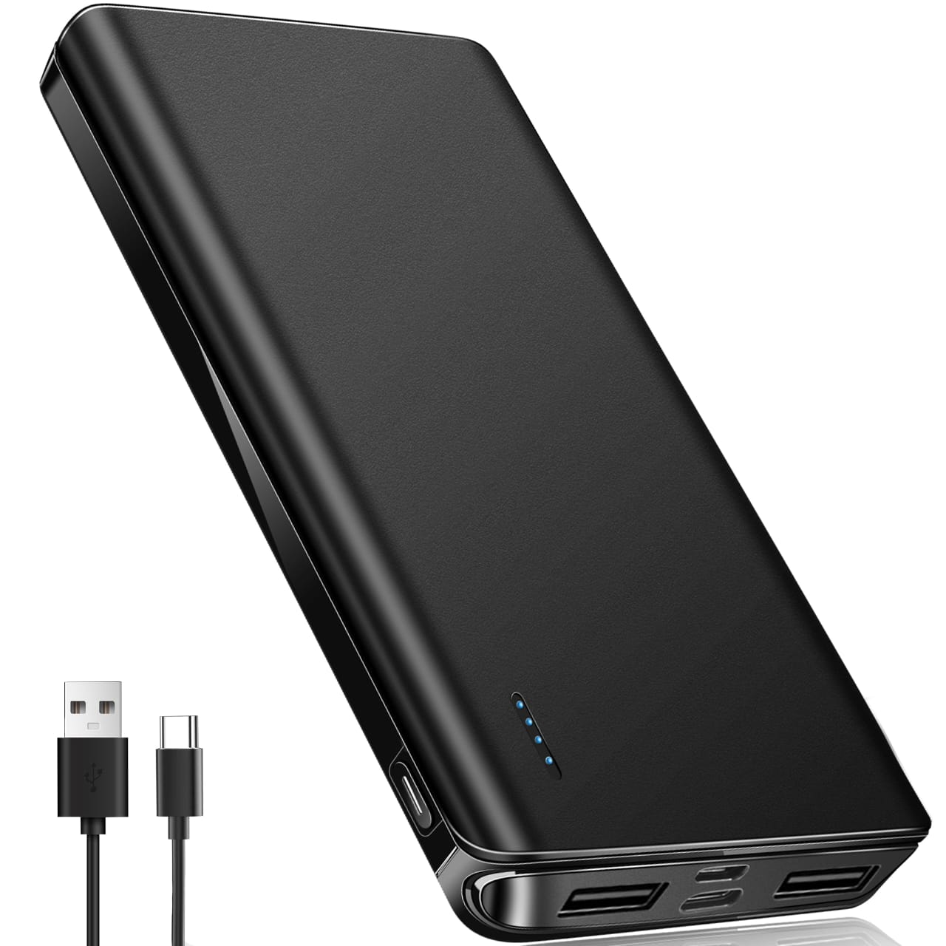

FIGURE 4.5

4.5.6 Farm Storage Structural Elements
The farm storage structural elements represent the physical storage environment where agricultural produce is stored. These elements include walls, roof, ventilation openings, and storage containers. The structural design influences internal temperature and humidity conditions.

Sensors are strategically placed within the storage structure to capture accurate environmental data. Understanding the interaction between structural elements and environmental conditions helps in effective monitoring and control of storage parameters.

4.6 Design Considerations
Several factors were considered during the design of the IoT-Based Smart Farm Monitoring and Automatic Ventilation System to ensure reliable performance, affordability, and ease of use. The system was designed using low-cost and readily available components such as the ESP32 microcontroller, DHT22 sensor, relay module, buzzer, and LCD display. These components were selected for their accuracy, low power consumption, compatibility, and suitability for agricultural monitoring applications.
Another important consideration was the integration of IoT technology for remote monitoring and control. The ESP32's built-in Wi-Fi capability enables seamless communication with the Blynk cloud platform, allowing users to access real-time environmental data from anywhere. The system was also designed with automatic ventilation functionality to respond quickly to high-temperature conditions. Reliability, scalability, energy efficiency, and ease of maintenance were considered throughout the design process to ensure that the system can effectively support smart farming and greenhouse monitoring applications.
  - System Advantages
- Provides real-time monitoring of temperature and humidity.
- Enables remote monitoring and control through the Blynk mobile application.
- Automatically activates the exhaust fan during high-temperature conditions.
- Generates buzzer alerts for immediate warning and safety.
- Uses low-cost and energy-efficient components, making it affordable for farmers.

CHAPTER 5
CIRCUIT DESIGN AND CONNECTIONS

5.1 Introduction
The circuit design of the IoT-Based Smart Farm Monitoring and Automatic Ventilation System focuses on establishing reliable connections between the sensing, processing, display, communication, and control components. Proper circuit design is essential to ensure accurate data collection, efficient signal processing, and stable operation of the entire system. The circuit integrates the DHT22 sensor, ESP32 microcontroller, relay module, exhaust fan, buzzer, LCD display, and power supply unit into a single monitoring and control platform.
The ESP32 serves as the central controller and interfaces with all peripheral devices. The DHT22 sensor provides temperature and humidity data to the ESP32, while the LCD display shows real-time readings locally. The relay module controls the exhaust fan based on temperature conditions, and the buzzer generates alerts during high-temperature situations. Through its built-in Wi-Fi capability, the ESP32 also communicates with the Blynk cloud platform for remote monitoring and control. This chapter describes the circuit connections, component interfacing, and electrical design considerations of the proposed system.
5.2 Circuit Diagram
The circuit diagram of the IoT-Based Smart Farm Monitoring and Automatic Ventilation System shows the electrical connections between the ESP32 microcontroller, DHT22 temperature and humidity sensor, 16×2 I2C LCD display, relay module, exhaust fan, buzzer, and power supply. The ESP32 acts as the central controller and receives environmental data from the DHT22 sensor. The LCD display is connected through the I2C communication interface to display real-time temperature and humidity readings. The relay module and buzzer are connected to the digital output pins of the ESP32 for automatic control and alert generation.
The circuit is designed to ensure reliable communication and efficient operation of all components. The ESP32 processes the sensor readings and controls the relay module based on the programmed temperature threshold. When the temperature exceeds 35°C, the relay activates the exhaust fan and the buzzer generates an alert. The ESP32 also uses its built-in Wi-Fi module to transmit sensor data to the Blynk cloud platform for remote monitoring and manual fan control through the mobile application. The circuit design provides accurate monitoring, automatic ventilation, and cloud connectivity in a compact and cost-effective system.
5.3 Pin Configuration of ESP32
The ESP32 microcontroller provides multiple GPIO pins that support digital communication protocols. Proper pin allocation is essential to avoid conflicts and ensure smooth operation of the system.

S.NO | Pin | Function | Connected Module
1 | 3.3V | Power Supply | ESP32, Sensors, I2C Display
2 | GND | Common Ground | ESP32, Sensors, Display, Buzzer
3 | Pin 4 | Sensor Data Input | Temperature & Humidity Sensor
4 | Pin 21 | I2C Display | I2CData Line (SDA)
5 | Pin 22 | I2C Clock Line (SCL) | I2C Display
6 | Pin 18 | Alert Control Output | Buzzer

5.4 Sensor Wiring and Connections
The DHT22 sensor is used to measure temperature and humidity in the farm environment and is connected directly to the ESP32 microcontroller. The sensor has three main connections: VCC, Data, and GND. The VCC pin of the DHT22 is connected to the 3.3V power supply of the ESP32, the GND pin is connected to the common ground, and the Data pin is connected to one of the digital input/output pins of the ESP32. The sensor continuously sends temperature and humidity data to the microcontroller for processing and monitoring.
Proper wiring of the DHT22 sensor is important to ensure accurate and reliable measurements. A pull-up resistor is typically connected between the VCC and Data pins to maintain stable communication between the sensor and the ESP32. Once connected, the ESP32 reads the sensor data at regular intervals, displays the values on the LCD screen, and transmits the information to the Blynk cloud platform. The sensor wiring is simple, cost-effective, and suitable for continuous environmental monitoring in smart farming applications.
5.5 Buzzer
The buzzer is used as an alert device in the IoT-Based Smart Farm Monitoring and Automatic Ventilation System. It provides an audible warning whenever the temperature exceeds the predefined threshold value of 35°C. The buzzer is connected to a digital output pin of the ESP32 microcontroller and is controlled automatically based on the sensor readings. This alert mechanism helps users quickly identify abnormal environmental conditions and take necessary actions if required.
When the ESP32 detects a temperature higher than the set limit, it activates the buzzer along with the exhaust fan to indicate a high-temperature condition. Once the temperature falls below the threshold value, the buzzer is automatically turned off. The use of a buzzer enhances system safety by providing immediate alerts and ensuring timely response to unfavorable environmental changes in the farm environment.
5.6 Display (I2C)
The 16×2 I2C LCD display is used to provide local visualization of temperature and humidity readings in the proposed system. The display receives data from the ESP32 microcontroller through the I2C communication protocol, which requires only two communication lines, namely Serial Data (SDA) and Serial Clock (SCL). This reduces the number of wiring connections and simplifies the overall circuit design. The LCD continuously displays real-time environmental data, allowing users to monitor farm conditions directly without accessing the mobile application.
The ESP32 processes the readings obtained from the DHT22 sensor and sends the information to the LCD for display. The temperature and humidity values are updated periodically to provide accurate and current environmental information. The use of an I2C LCD improves system usability by offering a simple and convenient method for local monitoring while reducing the number of GPIO pins required for interfacing. This makes the system more compact, efficient, and suitable for smart farming applications.
5.7 Power Supply Arrangement
The power supply arrangement is an important part of the IoT-Based Smart Farm Monitoring and Automatic Ventilation System, as it provides the required electrical power for all components. The ESP32 microcontroller, DHT22 sensor, I2C LCD display, relay module, and buzzer operate using a regulated DC power supply. A suitable 5V power source is used to power the ESP32 and peripheral devices, ensuring stable and reliable operation of the system.
The relay module controls the exhaust fan, which may require a separate power source depending on the fan's voltage and current requirements. Proper grounding is maintained among all components to ensure stable communication and prevent electrical noise. The power supply arrangement is designed to provide sufficient power, improve system reliability, and support continuous monitoring and automatic control operations in smart farming environments.

  - Circuit Reliability and Safety Measure
Circuit reliability and safety are important for ensuring the stable and continuous operation of the proposed system. All components are connected according to their specified voltage and current requirements, and a regulated power supply is used to prevent damage caused by power fluctuations. Proper grounding and secure wiring connections help reduce electrical noise and communication errors. The relay module provides isolation between the low-voltage control circuit and the exhaust fan, improving operational safety. These measures enhance system reliability, protect hardware components, and ensure safe and efficient performance in agricultural monitoring applications.

CHAPTER 6
WORKING PRINCIPLE

6.1 Introduction
The working principle of the IoT-Based Smart Farm Monitoring and Automatic Ventilation System is based on the continuous monitoring of environmental conditions and automatic control of ventilation equipment. The system uses a DHT22 sensor to measure temperature and humidity levels in the farm environment. The collected data is sent to the ESP32 microcontroller, which processes the information and displays the real-time readings on a 16×2 I2C LCD display. The sensor data is also transmitted to the Blynk cloud platform through Wi-Fi, enabling remote monitoring and visualization using a mobile application.
The system continuously compares the measured temperature with a predefined threshold value of 35°C. When the temperature exceeds this limit, the ESP32 activates the relay module, which switches on the exhaust fan, and simultaneously triggers the buzzer alarm to indicate a high-temperature condition. When the temperature falls below the threshold value, the fan and buzzer are automatically turned off. This working principle ensures real-time monitoring, automatic environmental control, and improved farm management through IoT technology.
6.2 Sensing and Data Acquisition Process
The sensing and data acquisition process begins with the DHT22 sensor continuously measuring the temperature and humidity of the farm environment. The sensor detects changes in environmental conditions and converts the measured values into digital data. This data is then transmitted to the ESP32 microcontroller through its data communication pin for further processing. The continuous sensing operation ensures that environmental parameters are monitored accurately and in real time.
The ESP32 receives the sensor data at regular intervals and processes the temperature and humidity readings. The acquired data is displayed on the 16×2 I2C LCD display for local monitoring and simultaneously transmitted to the Blynk cloud platform through the built-in Wi-Fi module. This process enables real-time data collection, remote access, cloud-based storage, and continuous monitoring of environmental conditions, allowing users to observe farm conditions from any location.
6.3 Monitoring and Display Operation
The monitoring and display operation of the system is carried out by the ESP32 microcontroller, which continuously receives temperature and humidity data from the DHT22 sensor. The microcontroller processes the sensor readings and updates the environmental information in real time. This continuous monitoring helps in detecting any changes in farm conditions and ensures that accurate data is always available for analysis and control.
The processed temperature and humidity values are displayed on the 16×2 I2C LCD display, allowing users to monitor environmental conditions directly at the farm site. At the same time, the ESP32 transmits the data to the Blynk cloud platform through Wi-Fi for remote monitoring using a mobile application. This dual-display approach provides both local and remote access to environmental information, improving convenience, monitoring efficiency, and decision-making in smart farming applications.
6.4 Data Logging and Alert Mechanism
The data logging mechanism of the proposed system stores temperature and humidity readings on the Blynk cloud platform for future reference and analysis. The ESP32 continuously sends sensor data to the cloud through its Wi-Fi connection, where the information is recorded and displayed in graphical form using the Blynk mobile application. This cloud-based data logging feature allows users to track environmental trends, review historical records, and analyze farm conditions over time.
The alert mechanism is activated whenever the temperature exceeds the predefined threshold value of 35°C. Under such conditions, the ESP32 automatically triggers the buzzer and activates the exhaust fan through the relay module. The buzzer provides an immediate audible warning, while the Blynk platform enables users to monitor the alert status remotely. Once the temperature returns to a safe level, the buzzer and fan are automatically turned off, ensuring efficient environmental control and timely response to abnormal conditions.
  - Overall System Flow
- The DHT22 sensor continuously measures temperature and humidity in the farm environment.
- The sensor data is sent to the ESP32 microcontroller for processing.
- The ESP32 displays the temperature and humidity readings on the 16×2 I2C LCD display.
- The processed data is transmitted to the Blynk cloud platform through Wi-Fi for remote monitoring.
- When the temperature exceeds 35°C, the ESP32 activates the relay module, turning on the exhaust fan and buzzer.
- When the temperature falls below 35°C, the exhaust fan and buzzer are automatically turned off, and normal monitoring continues.

CHAPTER 7
EXPERIMENTAL SETUP AND IMPLEMENTATION

7.1 Introduction
The experimental setup and implementation of the IoT-Based Smart Farm Monitoring and Automatic Ventilation System involve the integration of hardware and software components to achieve real-time environmental monitoring and automatic control. The system is developed using an ESP32 microcontroller, DHT22 temperature and humidity sensor, relay module, exhaust fan, buzzer, 16×2 I2C LCD display, and the Blynk cloud platform. These components are assembled and interconnected according to the designed circuit to ensure proper communication and reliable operation.
The implementation process includes configuring the ESP32, interfacing the sensor and output devices, establishing Wi-Fi connectivity, and integrating the system with the Blynk platform for remote monitoring. The experimental setup is tested under different temperature conditions to evaluate sensor performance, cloud communication, automatic fan operation, and alert generation. This chapter describes the hardware setup, software implementation, testing procedures, and system operation used to validate the performance of the proposed smart farm monitoring system.
7.2 Description of Storage Model
The storage model used in the proposed system represents a farm or greenhouse environment where temperature and humidity conditions are continuously monitored. The model consists of an enclosed space equipped with a DHT22 sensor, ESP32 microcontroller, exhaust fan, buzzer, and LCD display. The sensor is positioned to accurately measure the environmental conditions within the storage area, while the exhaust fan is installed to provide ventilation whenever the temperature exceeds the predefined threshold value.
The ESP32 receives temperature and humidity data from the DHT22 sensor and processes the information in real time. The measured values are displayed on the LCD screen and transmitted to the Blynk cloud platform for remote monitoring. When the temperature rises above 35°C, the ESP32 automatically activates the exhaust fan through a relay module and triggers the buzzer alarm. This storage model demonstrates how IoT technology can be used to maintain suitable environmental conditions, improve monitoring efficiency, and support smart agricultural management.
7.3 Sensor Placement in Storage
Proper placement of the DHT22 sensor is essential for obtaining accurate temperature and humidity measurements within the storage environment. The sensor is installed at a central location inside the storage model where it can effectively sense the overall environmental conditions. It is positioned away from direct airflow from the exhaust fan and away from heat-generating components to avoid inaccurate readings caused by localized temperature variations.
The sensor is mounted at an appropriate height to ensure uniform measurement of the surrounding air conditions. This placement allows the ESP32 microcontroller to receive reliable environmental data for monitoring and control purposes. Accurate sensor positioning improves the effectiveness of the automatic ventilation system, ensuring timely activation of the exhaust fan and buzzer when temperature levels exceed the predefined threshold.
7.4 Hardware Setup
The hardware setup of the proposed IoT-Based Smart Farm Monitoring and Automatic Ventilation System includes an ESP32 microcontroller, DHT22 temperature and humidity sensor, 16×2 I2C LCD display, relay module, exhaust fan, buzzer, and a regulated power supply. The DHT22 sensor continuously measures environmental conditions and sends the data to the ESP32 for processing. The LCD display shows real-time temperature and humidity readings, while the relay module controls the exhaust fan based on temperature conditions. The buzzer provides audible alerts during high-temperature situations. The ESP32 uses its built-in Wi-Fi capability to transmit sensor data to the Blynk cloud platform, enabling remote monitoring and control through a mobile application. All components are interconnected according to the circuit design to ensure reliable system operation and efficient environmental monitoring.

7.5 Software Implementation
The software implementation of the proposed system is carried out using the Arduino IDE, where the program code is developed and uploaded to the ESP32 microcontroller. The software initializes the DHT22 sensor, I2C LCD display, relay module, buzzer, and Wi-Fi communication. The ESP32 continuously reads temperature and humidity data from the DHT22 sensor, processes the values, and displays the information on the LCD screen. The program also establishes a connection with the Blynk cloud platform, enabling real-time data transmission, remote monitoring, and manual control of the exhaust fan through the mobile application.
The control algorithm compares the measured temperature with the predefined threshold value of 35°C. When the temperature exceeds this limit, the ESP32 automatically activates the relay module to switch on the exhaust fan and simultaneously triggers the buzzer alarm. When the temperature falls below the threshold value, the fan and buzzer are turned off automatically. The software ensures continuous monitoring, cloud connectivity, automatic ventilation, and efficient environmental management for smart farming applications.

7.6 Calibration and Testing
Calibration and testing were performed to ensure the accuracy and reliability of the IoT-Based Smart Farm Monitoring and Automatic Ventilation System. The DHT22 sensor readings were compared with standard temperature and humidity measurements to verify accuracy. The sensor was tested under different environmental conditions, and the displayed values on the LCD screen and Blynk platform were observed to ensure consistent and correct operation. Any minor deviations in readings were checked and adjusted through software calibration when necessary.
The complete system was tested to evaluate its monitoring, communication, and control functions. Temperature conditions above and below the threshold value of 35°C were simulated to verify the automatic operation of the exhaust fan and buzzer. The relay module successfully activated the fan and alarm during high-temperature conditions and turned them off when the temperature returned to normal. Cloud connectivity, remote monitoring, and manual fan control through the Blynk application were also tested, confirming the reliable performance of the proposed system.
7.7 Experimental Procedure
• Assemble and connect the ESP32, DHT22 sensor, LCD display, relay module, exhaust fan, and buzzer according to the circuit diagram.
• Upload the program code to the ESP32 and establish Wi-Fi connectivity with the Blynk cloud platform.
• Power on the system and verify the temperature and humidity readings displayed on the LCD screen and Blynk application.
• Simulate high-temperature conditions to check the automatic activation of the exhaust fan and buzzer when the temperature exceeds 35°C.
• Observe and record the system performance, including sensor readings, cloud data transmission, alert generation, and automatic fan operation under different environmental conditions.

7.8 Data Collection and Analysis Preparation
Data collection was carried out by continuously recording temperature and humidity readings obtained from the DHT22 sensor during system operation. The ESP32 transmitted the collected data to the Blynk cloud platform, where the information was stored and displayed in graphical form. Environmental conditions were monitored over different time intervals to observe variations in temperature and humidity and evaluate the performance of the monitoring system.
The collected data was analyzed to assess sensor accuracy, cloud communication reliability, and the effectiveness of the automatic ventilation mechanism. Particular attention was given to the system response when the temperature exceeded the threshold value of 35°C. The recorded observations were used to evaluate fan activation, buzzer alerts, and overall system performance. This analysis helped verify the reliability and efficiency of the proposed IoT-Based Smart Farm Monitoring and Automatic Ventilation System.

CHAPTER 8
COST ESTIMATION

8.1 Introduction
Cost estimation is an essential part of the project development process, as it helps determine the total expenditure required for designing and implementing the IoT-Based Smart Farm Monitoring and Automatic Ventilation System. The system is developed using affordable and readily available components, making it a cost-effective solution for smart agriculture applications. A detailed cost analysis of the hardware components is carried out to evaluate the economic feasibility of the proposed system and demonstrate its suitability for small and medium-scale farming environments.

8.2 Cost Estimation Methodology
The cost estimation for the proposed IoT-Based Smart Farm Monitoring and Automatic Ventilation System was carried out using the component-based estimation method. In this approach, the cost of each hardware component required for the system, such as the ESP32 microcontroller, DHT22 sensor, relay module, exhaust fan, buzzer, I2C LCD display, connecting wires, and power supply, was identified and calculated individually. The total project cost was obtained by summing the costs of all the components used in the system.
The estimation was based on the current market prices of the selected components and included only the direct material costs required for prototype development. The component-based estimation method provides a simple and accurate way to determine the overall project cost and evaluate the economic feasibility of the proposed system. This methodology helps ensure that the developed solution remains affordable and suitable for smart farming applications.

8.3 Component-Wise Cost Breakdown
Table 8.3 Cost Estimation of Components
S. No. | Component / Material | Quantity | Cost per Unit (₹) | Total Cost (₹)
1 | ESP 32 | 1 | 450 | 450
2 | Temperature and Humidity Sensor(DHT22) | 1 | 250 | 250
3 | I2C LCD Display | 1 | 200 | 200
4 | SD Card Module | 1 | 200 | 200
5 | Relay Module | 1 | 40 | 40
6 | Exhaust Fan | 1 | 80 | 80
7 | Buzzer and LED indicators | 1 set | 50 | 50
8 | Bread board/Jumper Wires | 1 set | 80 | 80
9 | Power supply battery | 1 | 200 | 200
 | Total Cost |  |  | 1550

8.4 Economic Feasibility
The proposed IoT-Based Smart Farm Monitoring and Automatic Ventilation System is economically feasible due to its low development cost, simple implementation, and minimal maintenance requirements. The use of affordable components such as the ESP32 microcontroller, DHT22 sensor, relay module, exhaust fan, buzzer, and I2C LCD display makes the system suitable for small and medium-scale farmers. In addition, the system helps reduce labor costs, minimizes losses caused by unfavorable environmental conditions, and improves overall farm management efficiency. These benefits make the proposed solution a cost-effective and practical option for smart agriculture applications.

8.5 Comparison with Conventional Storage Systems
The proposed IoT-Based Smart Farm Monitoring and Automatic Ventilation System offers several advantages over conventional storage and monitoring methods. Traditional systems mainly rely on manual observation and periodic inspections, which can lead to delayed detection of unfavorable environmental conditions. In contrast, the proposed system provides continuous real-time monitoring of temperature and humidity, enabling immediate detection of environmental changes and faster response to potential problems.
Furthermore, conventional systems generally lack remote monitoring and automatic control features, requiring constant human supervision. The proposed system integrates cloud-based monitoring through the Blynk platform and automatically activates ventilation and alert mechanisms when high-temperature conditions occur. This improves operational efficiency, reduces labor requirements, minimizes environmental risks, and provides a more reliable and cost-effective solution for modern agricultural applications.

CHAPTER 9
RESULTS AND ANALYSIS

9.1 Introduction
This chapter presents the results obtained from the implementation and testing of the IoT-Based Smart Farm Monitoring and Automatic Ventilation System. The performance of the system was evaluated based on temperature and humidity monitoring, cloud data transmission, automatic exhaust fan operation, and buzzer alert generation. The experimental results demonstrate the effectiveness of the proposed system in providing real-time environmental monitoring, remote accessibility, and automatic control, making it a reliable and cost-effective solution for smart farming applications.
9.2 Temperature Data Collection
Temperature data was collected using the DHT22 sensor, which continuously monitored the environmental conditions within the farm storage model. The sensor measured temperature values at regular intervals and transmitted the readings to the ESP32 microcontroller for processing. The collected data was displayed on the 16×2 I2C LCD screen and simultaneously uploaded to the Blynk cloud platform for remote monitoring and storage.
The recorded temperature data was used to evaluate the performance of the monitoring system and the effectiveness of the automatic ventilation mechanism. When the measured temperature exceeded the predefined threshold value of 35°C, the system automatically activated the exhaust fan and buzzer. The collected temperature readings confirmed that the system could accurately detect environmental changes and respond appropriately, ensuring efficient monitoring and control of farm conditions.

9.3 Storage Condition Evaluation
The storage condition evaluation was conducted to assess the effectiveness of the proposed system in maintaining a suitable environment within the storage model. Temperature and humidity levels were continuously monitored using the DHT22 sensor, and the collected data was analyzed to observe environmental variations over time. The LCD display and Blynk platform provided real-time information, enabling effective monitoring of storage conditions.
The evaluation showed that the system successfully detected changes in environmental conditions and responded appropriately through its automatic control mechanism. When the temperature exceeded the threshold value of 35°C, the exhaust fan and buzzer were activated, helping to improve ventilation and reduce excessive heat. The results indicate that the proposed system can effectively monitor and manage storage conditions, contributing to better environmental stability and reduced risk of crop deterioration.
9.4 Performance of Monitoring System
The performance evaluation of the IoT-Based Smart Farm Monitoring and Automatic Ventilation System demonstrated reliable and efficient operation under different environmental conditions. The DHT22 sensor accurately measured temperature and humidity levels, while the ESP32 successfully processed and transmitted the data to both the LCD display and the Blynk cloud platform. The system provided real-time monitoring, remote accessibility, and continuous data logging. The automatic control mechanism responded effectively when the temperature exceeded 35°C by activating the exhaust fan and buzzer, and deactivating them when the temperature returned to normal. The overall results confirmed that the system operates efficiently, provides stable performance, and is suitable for smart farming and environmental monitoring applications.

9.5 Reduction in Spoilage Risk
The proposed IoT-Based Smart Farm Monitoring and Automatic Ventilation System helps reduce spoilage risk by continuously monitoring temperature and humidity levels within the storage environment. Real-time detection of unfavorable conditions allows timely corrective actions before they can negatively affect stored agricultural produce. The automatic activation of the exhaust fan and buzzer when the temperature exceeds 35°C helps maintain a stable environment and prevents excessive heat buildup. By ensuring proper environmental control, the system minimizes the chances of microbial growth, moisture-related damage, and quality deterioration, thereby reducing post-harvest losses and extending the storage life of farm produce.
9.6 Graphical Representation of Results
The experimental results were graphically represented using the Blynk cloud platform, which displayed temperature and humidity variations over time through charts and trend graphs. These graphical representations helped visualize environmental changes within the storage model and provided a clear understanding of system performance. The graphs showed the continuous monitoring capability of the DHT22 sensor and the successful transmission of data from the ESP32 to the cloud platform.
The graphical analysis also illustrated the operation of the automatic ventilation mechanism. Whenever the temperature exceeded the threshold value of 35°C, the system activated the exhaust fan and buzzer, which helped bring the temperature back to a safe range. The plotted data confirmed the effectiveness of real-time monitoring, cloud-based data logging, and automatic environmental control. The graphical representation therefore validated the reliability and efficiency of the proposed IoT-Based Smart Farm Monitoring and Automatic Ventilation System.
9.7 Limitations of the System
Although the proposed IoT-Based Smart Farm Monitoring and Automatic Ventilation System provides effective environmental monitoring and automatic control, it has certain limitations. The system primarily monitors temperature and humidity and does not include additional parameters such as soil moisture, gas concentration, or light intensity. Its operation also depends on a stable Wi-Fi connection for cloud communication and remote monitoring through the Blynk platform. Any network interruption may temporarily affect remote access to real-time data.
Another limitation is that the system uses a fixed temperature threshold value for fan activation, which may not be suitable for all types of crops or storage conditions. The DHT22 sensor, while cost-effective, may have slight measurement variations under extreme environmental conditions. Additionally, the prototype is designed for small-scale applications and may require further modifications and additional hardware for large-scale agricultural storage facilities. Despite these limitations, the system remains a practical and affordable solution for smart farm monitoring and automatic ventilation.

CHAPTER 10
ADVANTAGES AND APPLICATIONS

10.1 Introduction
The IoT-Based Smart Farm Monitoring and Automatic Ventilation System is designed to improve agricultural management through real-time monitoring, cloud connectivity, and automatic environmental control. By continuously measuring temperature and humidity, the system helps maintain suitable farm conditions and reduces the risk of crop damage caused by unfavorable environmental factors. The integration of the ESP32 microcontroller, DHT22 sensor, Blynk cloud platform, exhaust fan, and buzzer enables remote monitoring, data logging, and automatic ventilation, reducing manual effort and improving operational efficiency. Its low-cost design, ease of implementation, and reliable performance make it suitable for various applications such as smart farming, greenhouse management, livestock monitoring, and agricultural storage systems.

10.2 Advantages of Low Cost Storage Monitoring
10.2.1 Energy Efficiency
The proposed IoT-Based Smart Farm Monitoring and Automatic Ventilation System is energy efficient because it uses low-power components and operates the exhaust fan only when required. The automatic control mechanism ensures that energy is not wasted by continuously running the ventilation system. This reduces power consumption, lowers operating costs, and supports sustainable agricultural practices.

10.2.2 Cost Effectiveness
The proposed IoT-Based Smart Farm Monitoring and Automatic Ventilation System is highly cost-effective because it utilizes affordable and readily available components such as the ESP32 microcontroller, DHT22 sensor, relay module, buzzer, and LCD display. The system reduces the need for continuous manual monitoring and helps prevent losses caused by unfavorable environmental conditions. Its low installation and maintenance costs make it a practical and economical solution for small and medium-scale farmers.

10.2.3 Environmentally Friendly
The proposed IoT-Based Smart Farm Monitoring and Automatic Ventilation System is environmentally friendly because it promotes efficient use of energy and resources through automated monitoring and control. By operating the exhaust fan only when necessary, the system minimizes unnecessary power consumption and reduces energy wastage. Its ability to maintain suitable environmental conditions helps reduce crop losses and supports sustainable agricultural practices, contributing to a greener and more efficient farming environment.

10.2.4 Improved Thermal Comfort
The proposed IoT-Based Smart Farm Monitoring and Automatic Ventilation System improves thermal comfort by continuously monitoring temperature levels and automatically controlling ventilation when excessive heat is detected. When the temperature exceeds the predefined threshold value, the exhaust fan is activated to remove hot air and maintain a more stable environment. This helps create suitable conditions for stored agricultural produce, greenhouse crops, and livestock, thereby improving overall environmental quality and reducing the risk of heat-related damage.

10.2.5 Low Maintenance Requirements
The proposed IoT-Based Smart Farm Monitoring and Automatic Ventilation System requires minimal maintenance due to its simple design and use of reliable electronic components. The ESP32 microcontroller, DHT22 sensor, relay module, and LCD display operate efficiently with little routine servicing. The automated monitoring and control functions reduce manual intervention, while the cloud-based monitoring feature allows users to supervise the system remotely. As a result, the system offers dependable performance with low maintenance costs, making it suitable for long-term agricultural applications.

10.2.6 Scalability and Adaptability
The proposed IoT-Based Smart Farm Monitoring and Automatic Ventilation System is highly scalable and adaptable, allowing it to be expanded according to different agricultural requirements. Additional sensors and control devices can be integrated to monitor parameters such as soil moisture, light intensity, and air quality. The system can also be adapted for various applications, including greenhouse management, livestock monitoring, agricultural storage facilities, and smart farming environments. This flexibility makes the system suitable for both small-scale and large-scale agricultural operations.

10.3 Applications in Agriculture |
10.3.1 Grain Storage
The proposed IoT-Based Smart Farm Monitoring and Automatic Ventilation System can be effectively used in grain storage facilities to maintain suitable environmental conditions and prevent spoilage. Continuous monitoring of temperature and humidity helps detect unfavorable conditions that may lead to moisture accumulation, mold growth, insect infestation, and quality deterioration. The automatic ventilation system helps regulate the storage environment by removing excess heat and maintaining optimal conditions for stored grains. This improves grain quality, reduces post-harvest losses, and increases the overall storage life of agricultural produce.

10.3.2 Vegetable Storage
The proposed IoT-Based Smart Farm Monitoring and Automatic Ventilation System can be used in vegetable storage facilities to continuously monitor temperature and humidity levels and maintain suitable storage conditions. The automatic ventilation mechanism helps prevent excessive heat buildup, reducing spoilage, preserving freshness, and extending the shelf life of stored vegetables while minimizing post-harvest losses.

10.3.3 Fruit Storage
The proposed IoT-Based Smart Farm Monitoring and Automatic Ventilation System is suitable for fruit storage applications, where maintaining proper temperature and humidity is essential for preserving freshness and quality. Continuous environmental monitoring and automatic ventilation help prevent excessive heat and moisture buildup, reducing spoilage and extending the shelf life of stored fruits. This improves storage efficiency, minimizes post-harvest losses, and helps maintain the market value of the produce.

10.3.4 Cold Storage Support Systems
The proposed IoT-Based Smart Farm Monitoring and Automatic Ventilation System can be used as a support system in cold storage facilities to continuously monitor temperature and humidity conditions. Real-time monitoring helps ensure that environmental parameters remain within the required range, while automatic alerts notify users of any abnormal conditions. This assists in maintaining product quality, reducing spoilage, improving storage efficiency, and supporting the effective operation of cold storage systems.

11. APPENDICES

11.1 FIELD VISIT

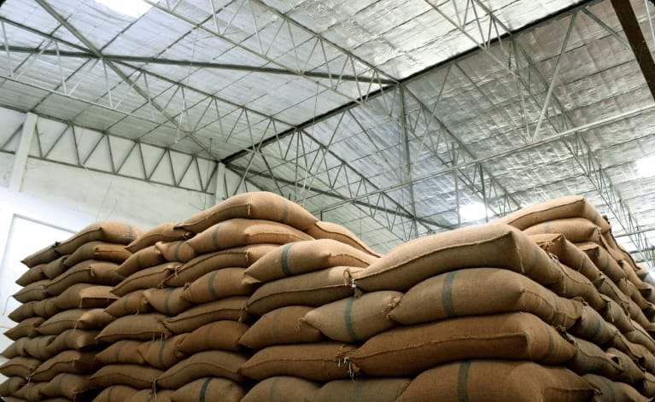
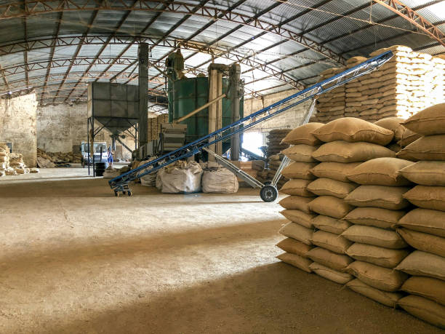
FIGURE 11.1 FIGURE 11.2

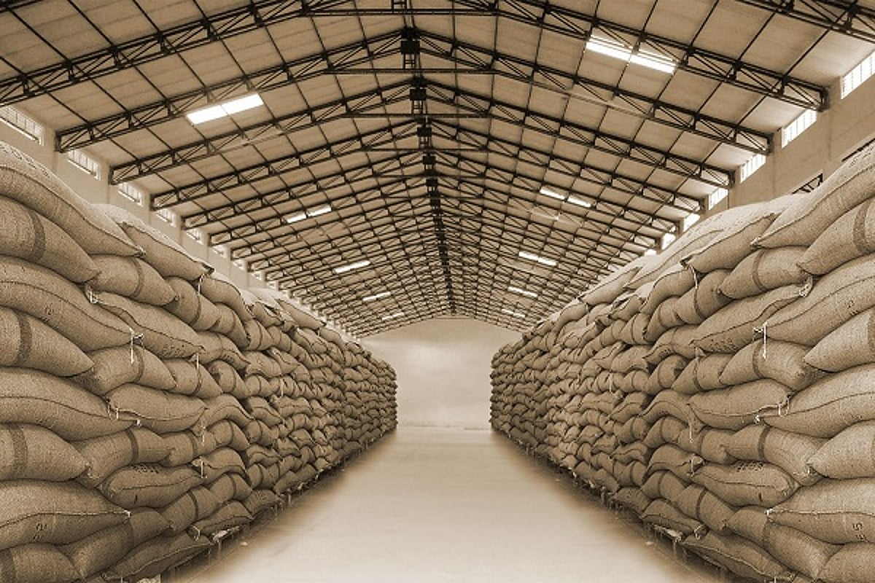

FIGURE 11.3
11.2 PROTOTYPE

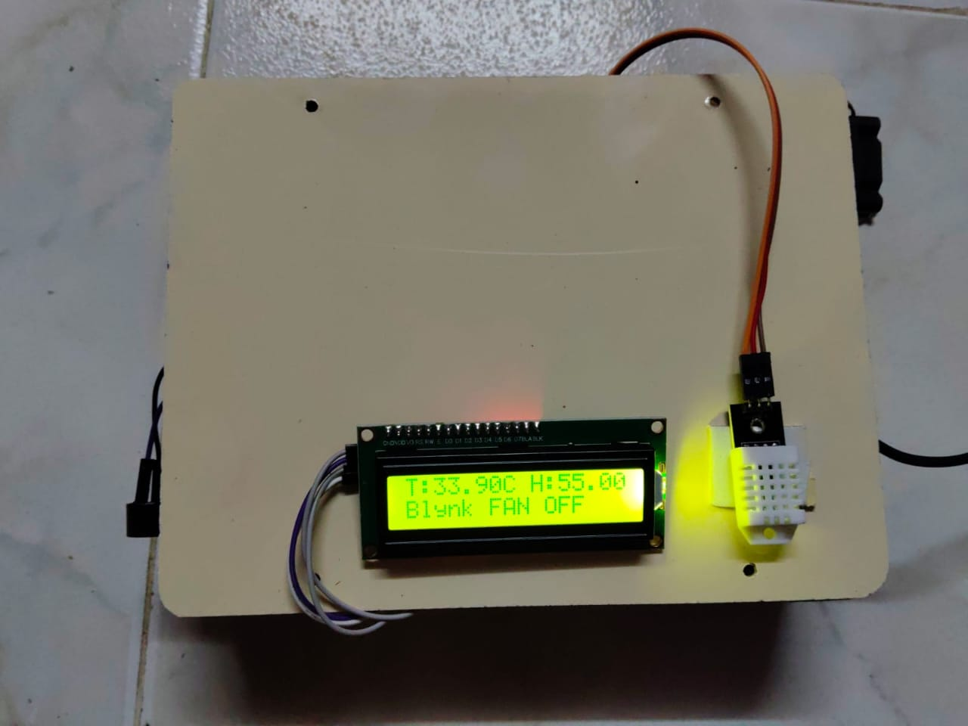

FIGURE 11.4

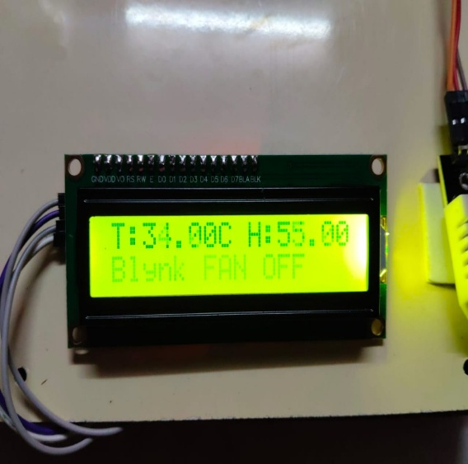

FIGURE 11.5

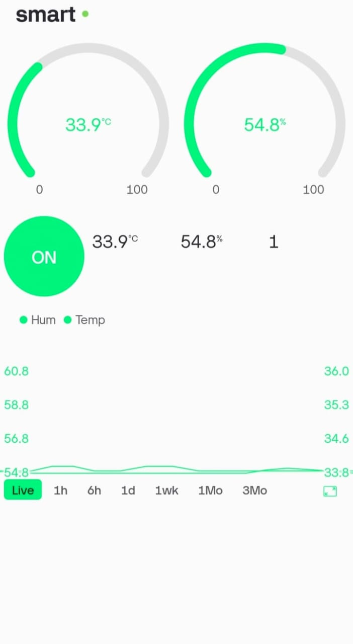

FIGURE 11.6

12 .CONCLUSION

The IoT-Based Smart Farm Monitoring and Automatic Ventilation System was successfully designed and implemented to provide real-time monitoring of temperature and humidity in agricultural environments. The system utilizes an ESP32 microcontroller, DHT22 sensor, relay module, exhaust fan, buzzer, LCD display, and the Blynk cloud platform to monitor environmental conditions and provide automatic control. The collected data is displayed locally and remotely, enabling users to monitor farm conditions from any location through a mobile application.The experimental results demonstrated that the system accurately measures environmental parameters, transmits data to the cloud platform, and automatically activates the exhaust fan and buzzer when the temperature exceeds the predefined threshold value of 35°C. The automatic control mechanism helps maintain a stable environment, reducing the risk of spoilage and improving farm management efficiency. The integration of cloud-based monitoring and remote accessibility further enhances the usability and effectiveness of the system.The proposed system offers a low-cost, energy-efficient, and reliable solution for smart agriculture applications. It reduces manual monitoring efforts, supports timely decision-making, and helps maintain suitable environmental conditions for agricultural produce. Therefore, the IoT-Based Smart Farm Monitoring and Automatic Ventilation System can be considered an effective and practical solution for smart farming, greenhouse management, storage monitoring, and other agricultural applications.

